 | Contract Management System  Technical Design Document  1.0
 | Prepared By / Last Updated By | Reviewed By | Approved By
Name | Saiayyappa O R, Vineka Vellimalai, Vignesh U, Deepika Gnanamoorthy. | Saiayyappa O R, Vineka Vellimalai, Vignesh U, Deepika Gnanamoorthy. | Poonkuzhali Anand.
Role | Team Member | Team Member | Scrum Master
Signature
Date

Table of Contents

1.0 Introduction 3
1.1 Purpose of this document 3
1.2 Scope 3
1.3 Intended Audience 3
1.4 Definition & Acronyms 3
2.0 Conventions and Standards Followed 4
3.0 Assumptions, Dependencies and Risks 4
3.1 Assumptions: 4
3.2 Dependencies: 4
4.0 Schematic Diagram 4
5.0 Use Case Realization 5
5.1.1 User Registration 5
a. Functional Requirement 6
b. UI Validations 6
c. UI Controls 7
d. UI Methods Definition 8
e. UI Design 9
6.0 Database Design 10
6.1 Data Model 10
6.2 Tables Structure 10
7.0 Change Log 13

Introduction

Purpose of this document
The purpose of the detail design document is to define the detailed design for all the components of Contract Management system that are specified in the Business Requirement/Use case document. All the low level components, interfaces and integrations are detailed out in this document.

Scope
This sub-section shall state the scope of this detailed design document
• Create and maintain Admin information.
• Create and maintain Supplier information

Intended Audience
The intended audience for this document are
- Developers, testers, other associates in the project
- Technical lead, Scrum Master
- Product Owner

Definition & Acronyms
Acronyms | Definitions
CMS | Contract Management System

Conventions and Standards Followed
The modules under scope needs to adhere to the coding standards and guidelines
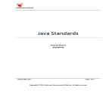
(Click the above icon for java standards and guidelines)

Assumptions, Dependencies and Risks

Assumptions:
- Once the application is built the Contract Management System will manually load the user list into the system.
- There will be no concurrent users for the application. The Supplier profile will be maintained by the Admin.
- Any changes to the design mentioned in the BRD would be taken as a Change Request

Dependencies:
- Availability of database design characteristics & access shall be defined by the
- Resource availability throughout each of the sprint

Schematic Diagram
A schematic, or schematic diagram, is a representation of the elements of a system using abstract, graphic symbols rather than realistic pictures. It gives an overview of overall system

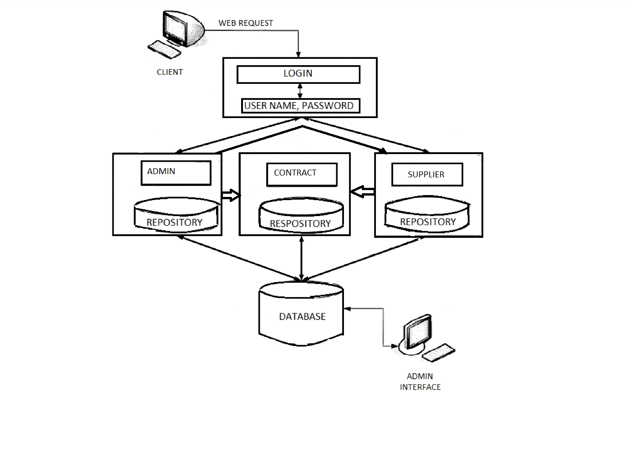
The above pic is only an example and not representational of the Contract Management System

Use Case Realization

User Registration
5.1.1.1 Login Page

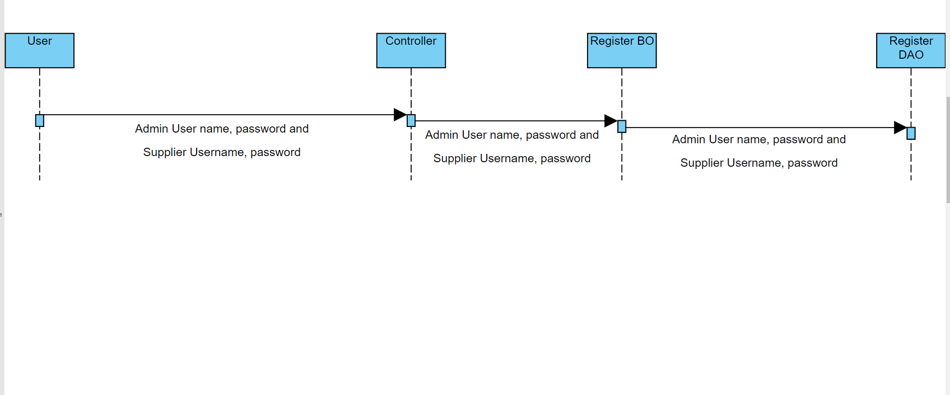

5.1.1.2 Supplier Registration Page
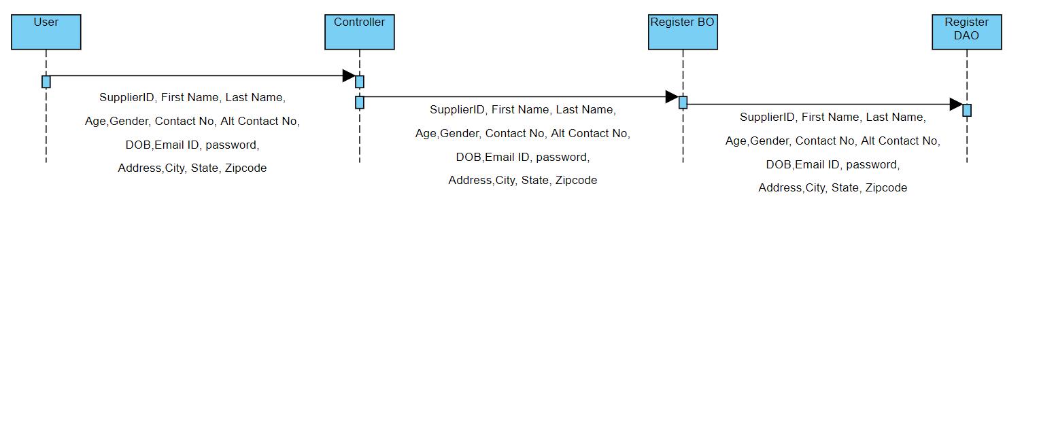

5.1.1.3 Admin Registration Page
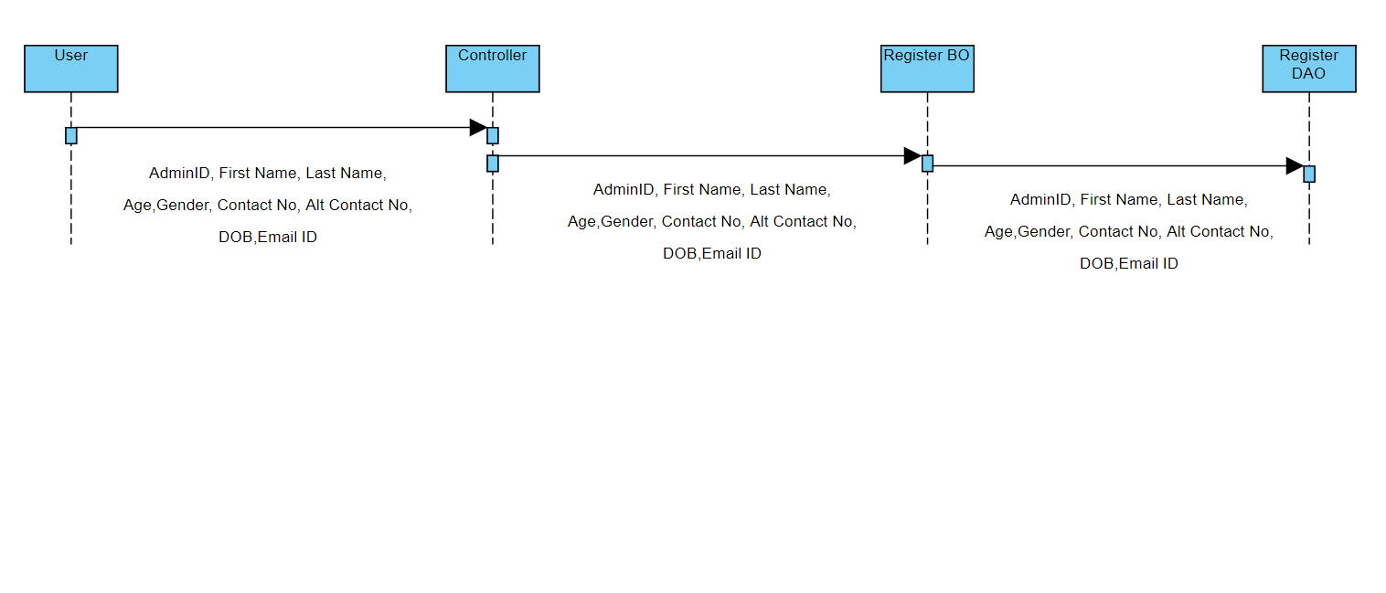
5.1.1.4 Create Contract Page
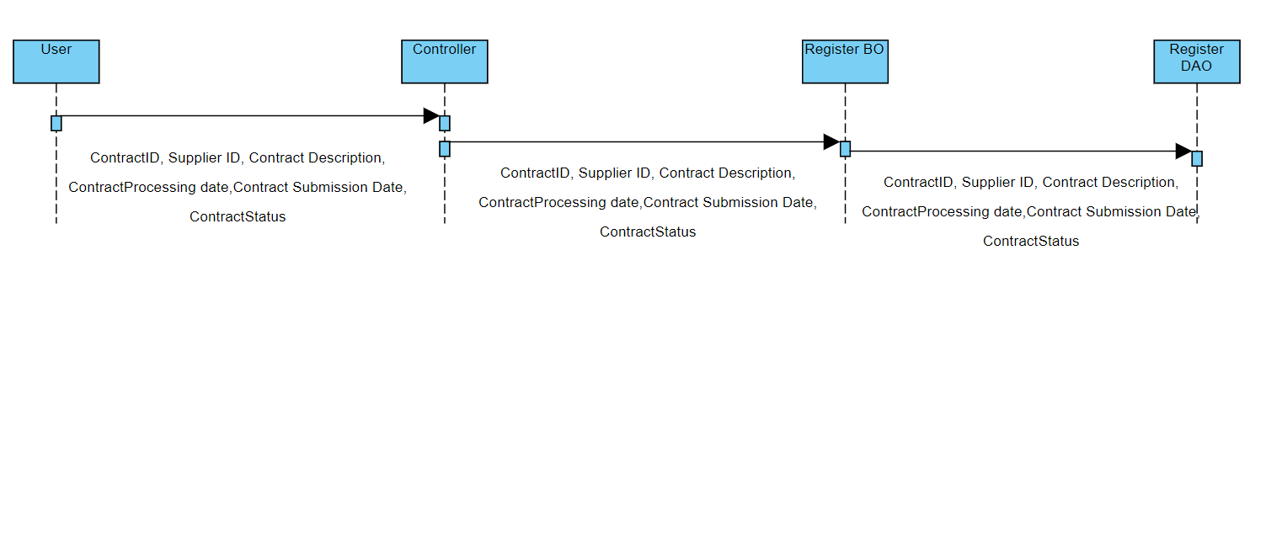

Functional Requirement
. Login Page checks the authentication of the user and based on his role, directs the user to the respective page. User will provided with Add Patient, Details, Regulation and Search regulation pages and the same user will allowed to see Diagnosis Reports and patient vital parameters reports

UI Validations
- User Id and Password fields are mandatory.
- Invalid User Id and / or password should not allow the user to get into the system

UI Controls
# | UI Component | Type | Name | Details
1 | Admin/Supplier Id | Label | UserId
2 | Admin/Supplier Id | Text field | adminId, supplierId | To enter user id
3 | password | Label | Password
4 | password | Text field | password | To enter password
-

UI Methods Definition
Method Name | Parameter | Details
loginAdmin | @ModelAttribute("command") AdminBean adminBean1, BindingResult result, HttpSession session | Allows the Admin to login
saveAdmin | @ModelAttribute("command") AdminBean adminBean, BindingResult result, HttpSession session | Allows the Admin to register
loginSupplier | @ModelAttribute("command") SupplierBean supplierBean1, HttpSession session | Allows the Supplier to login
saveSupplier | @ModelAttribute("command") SupplierBean supplierBean, BindingResult result, HttpSession session | Allows the Supplier to register
addContract | @RequestParam("supplierId") int supplierId, @ModelAttribute("command") ContractBean contractBean, BindingResult result, HttpSession session | Allows the supplier to create the contract with Contract description, Terms and Conditions and Amenities should be submitted to ADMIN for approval.

viewContract | @RequestParam("supplierId") int supplierId, HttpSession session | It should display all the contracts created by the Supplier.
fetchContract | @RequestParam("contractId") int contractId, HttpSession session | It should display the single contract detail.
updateContract | @RequestParam("supplierId") int supplierId,@ModelAttribute("command") ContractBean contractBean, BindingResult result, HttpSession session | It should allow editing or modifying of the contract.
deleteContract | @RequestParam("contractId") int contractId,@RequestParam("supplierId") int supplierId, HttpSession session | It should delete the selected contract.
updateContractStatus | @ModelAttribute("command") ContractBean contractBean, BindingResult result,HttpSession session | It should update the status of the contract (Approved/rejected)
fetchContractUsingStatus | @RequestParam("contractStatus") String contractStatus,HttpSession session | It should display the contract details based on the status.
fetchSupplier | @RequestParam("supplierStatus") String status, HttpSession session | It should display the single supplier detail.
updateSupplierStatus | @ModelAttribute("command") SupplierBean supplierBean, BindingResult result, HttpSession session | It should update the status of the supplier.
fetchAllSuppliers | HttpServletRequest request, HttpSession session | It should display all the suppliers approved by the admin.
logout | HttpServletRequest request, HttpServletResponse response, HttpSession session | It should invalidate the session.

UI Design

Database Design

Data Model

The following is a schematic view of the database design
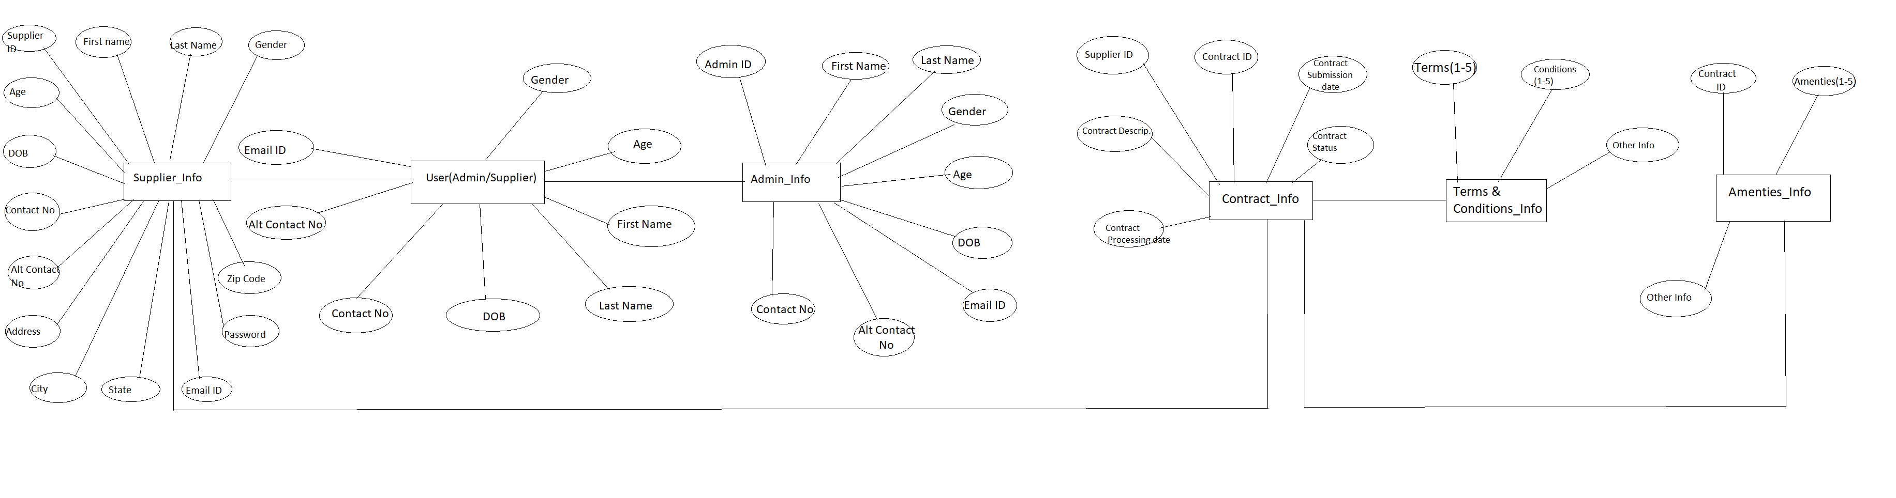

Tables Structure

Supplier Registration:
Field Name | Field Type | Data Type | Mandatory
Supplier ID | Text(10) | Alphabetic | Yes
First Name | Text(50) | Alphabetic | Yes
Last Name | Text(50) | Alphabetic | Yes
Age | Numeric(2) | Numeric | Yes
Gender | Drop Down | NA
DoB | Text(10) | Alphanumeric | No
Contact Number | Text(10) | Numeric | Yes
Alt Contact Number | Text(10) | Numeric | No
Email ID | Text(50) | Alphanumeric | Yes
Password | Text(15) | Alphanumeric | Yes
Address Line 1 | Text(100) | Alphanumeric | Yes
Address Line 1 | Text(100) | Alphabetic | Yes
City | Text(50) | Alphabetic | Yes
State | Text(50) | Alphabetic | Yes
Zip Code | Text(10) | Numeric | Yes

Supplier login:
Field Name | Field Type | Data Type | Mandatory
Supplier ID | Text(10) | Alphabetic | Yes
Password | Text(15) | Alphanumeric | Yes

Admin Registration:
Field Name | Field Type | Data Type | Mandatory | Possible Values
Admin ID | Text(10) | Alphabetic | Yes | System Generated
First Name | Text(50) | Alphabetic | Yes
Last Name | Text(50) | Alphabetic | Yes
Age | Numeric(2) | Numeric | Yes
Gender | Drop Down | NA |  | Male, Female
DoB | Text(10) | Alphanumeric | Yes
Contact Number | Text(10) | Numeric | Yes
Alt Contact Number | Text(10) | Numeric | No
Email ID | Text(50) | Alphanumeric | Yes
Password | Text(15) | Alphanumeric | Yes | Password

Admin login:
Field Name | Field Type | Data Type | Mandatory
Admin ID | Text(10) | Alphabetic | Yes
Password | Text(15) | Alphanumeric | Yes

Contract:
Field Name | Field Type | Data Type | Mandatory | Possible Values | Field Name
Contract ID | Auto- generated(8) | Numeric | Yes | Non- editable system generated | Contract ID
Contract Description | Text(200) | Alphabetic | Yes |  | Contract Description
Contract Submission Date | Text(10) | Alphanumeric | Yes |  | Contract Submission Date
Contract Processing Date | Text(10) | Alphanumeric | Yes |  | Contract Processing Date
Contract status | Text (10) Drop down | Alphabetic | Yes | Submitted Approved Denied | Contract status

Terms & Conditions:
Field Name | Field Type | Data Type | Mandatory | Possible Values
Contract ID | Auto- generated(8) | Numeric | Yes
Term1 | Text(100) | Alphabetic | Yes
Term2 | Text(100) | Alphabetic | No
Term3 | Text(100) | Alphabetic | No
Term4 | Text(100) | Alphabetic | No
Term5 | Text(100) | Alphabetic | No
Condition1 | Text(100) | Alphabetic | Yes
Condition2 | Text(100) | Alphabetic | No
Condition3 | Text(100) | Alphabetic | No
Condition4 | Text(100) | Alphabetic | No
Condition5 | Text(100) | Alphabetic | No

Amenities:
Field Name | Field Type | Data Type | Mandatory | Possible Values
Contract ID | Auto- generated(8) | Numeric | Yes
Amenities1 | Text(100) | Alphabetic | Yes
Amenities2 | Text(100) | Alphabetic | No
Amenities3 | Text(100) | Alphabetic | No
Amenities4 | Text(100) | Alphabetic | No
Amenities5 | Text(100) | Alphabetic | No
Other Info | Text(100) | Alphabetic | No

Change Log
Please note that this table needs to be maintained even if a Configuration Management tool is used.
Version Number | Changes made
V1.0 | <First version>
V1.1 | <If the change details are not explicitly documented in the table below, reference should be provided here>
V1.1 | Page no | Changed by | Effective date | Changes effected
V1.2 | <If the change details are not explicitly documented in the table below, reference should be provided here>
V1.2 | Page no | Changed by | Effective date | Changes effected

